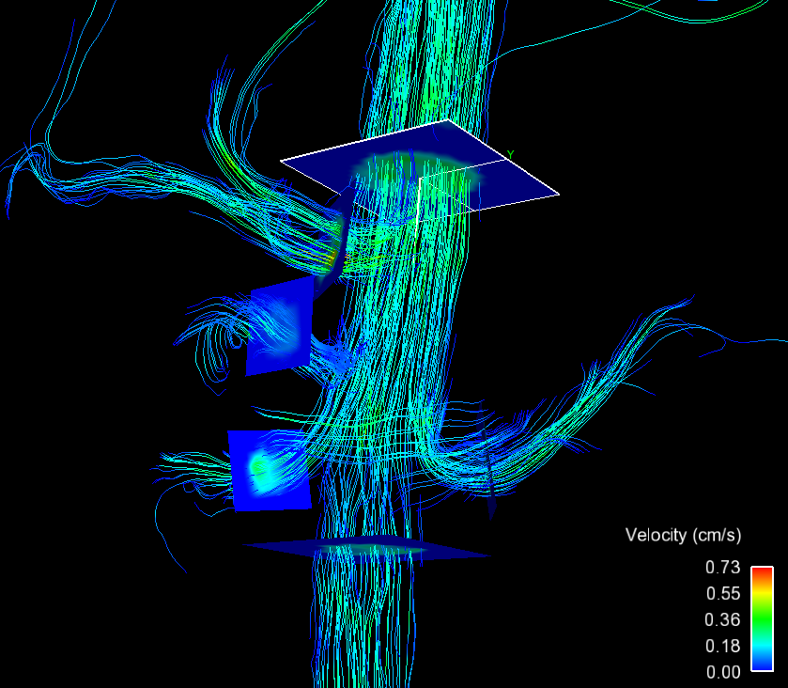

SCAo

CA

LRA

SMA

RRA

IRAo

PV

SV

SMV

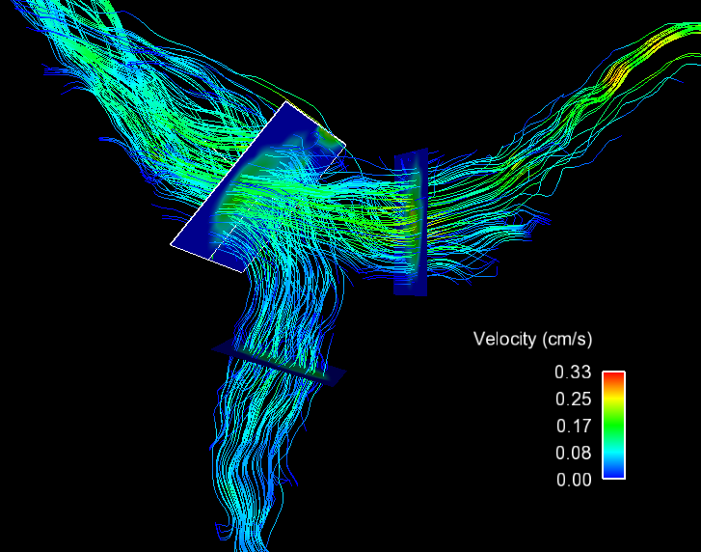

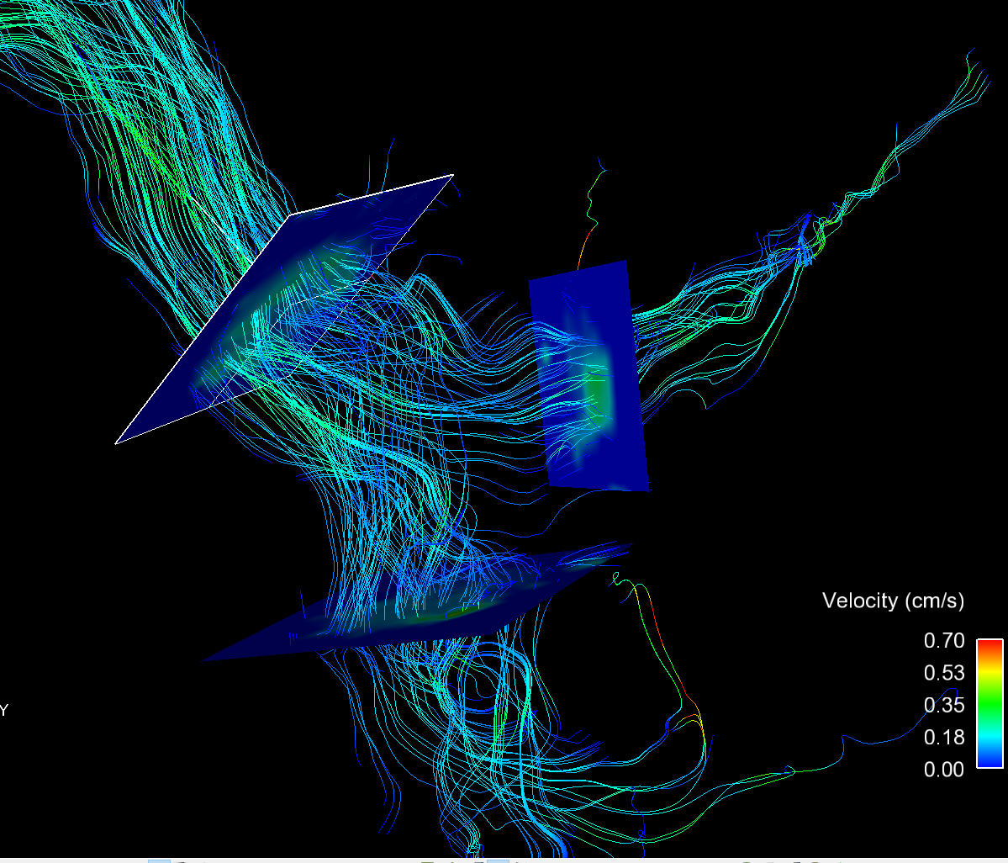

SMV

PV

SV

LRA

CA

SMA

RRA

IRAo

SCAo

Figure 1: Control subject, demonstrating a normal response to meal challenge.

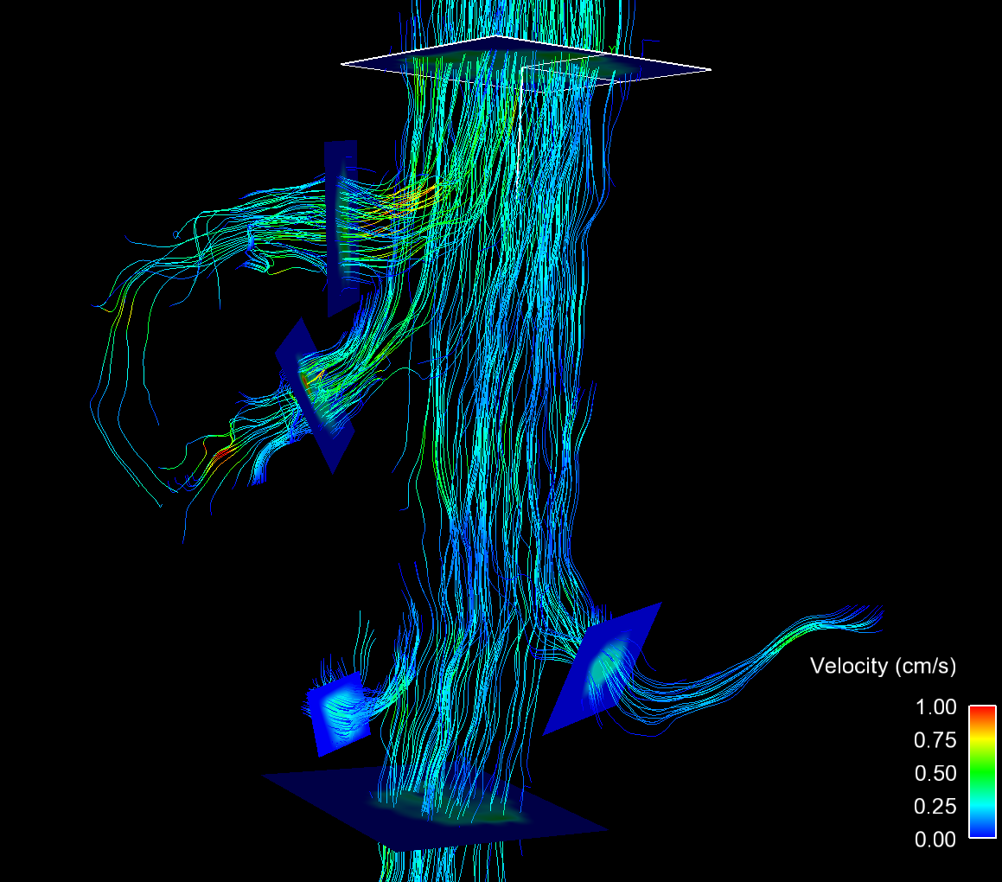

LRA

IRAo

RRA

SMA

CA

SCAo

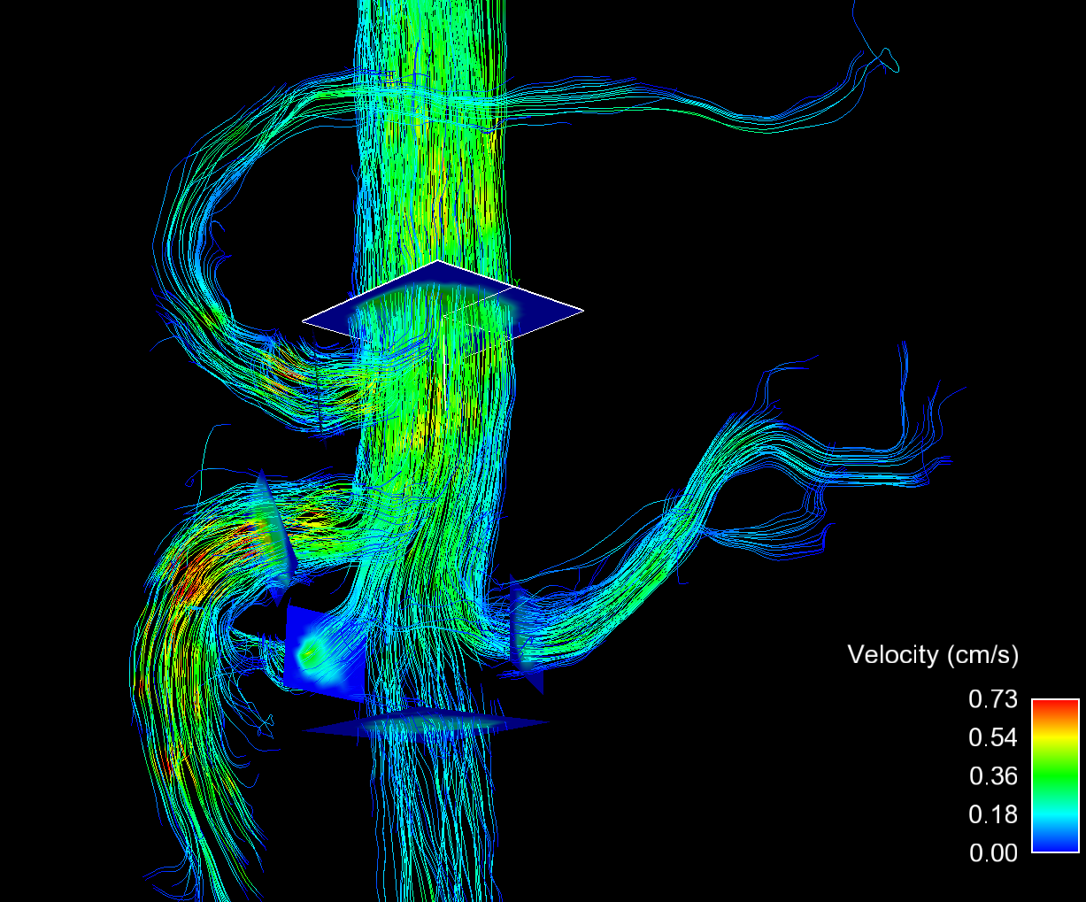

RRA

SMA

CA

SCAo

LRA

IRAo

a

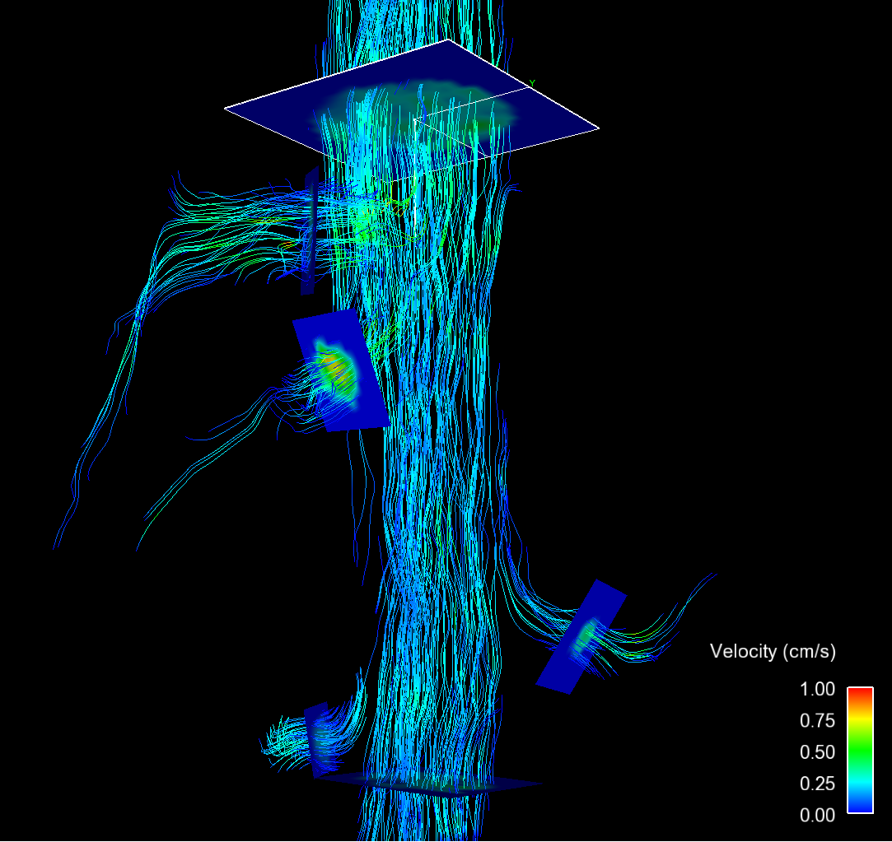

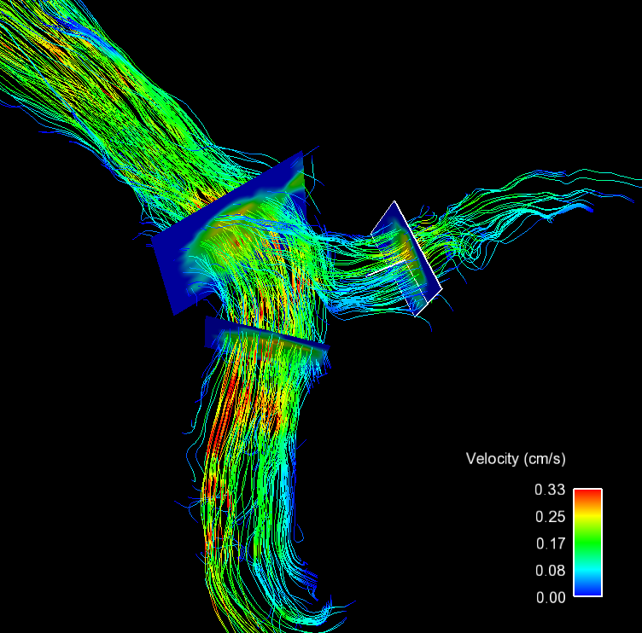

SMA

SCAo

IRAo

LRA

CA

RRA

SV

PV

SMV

a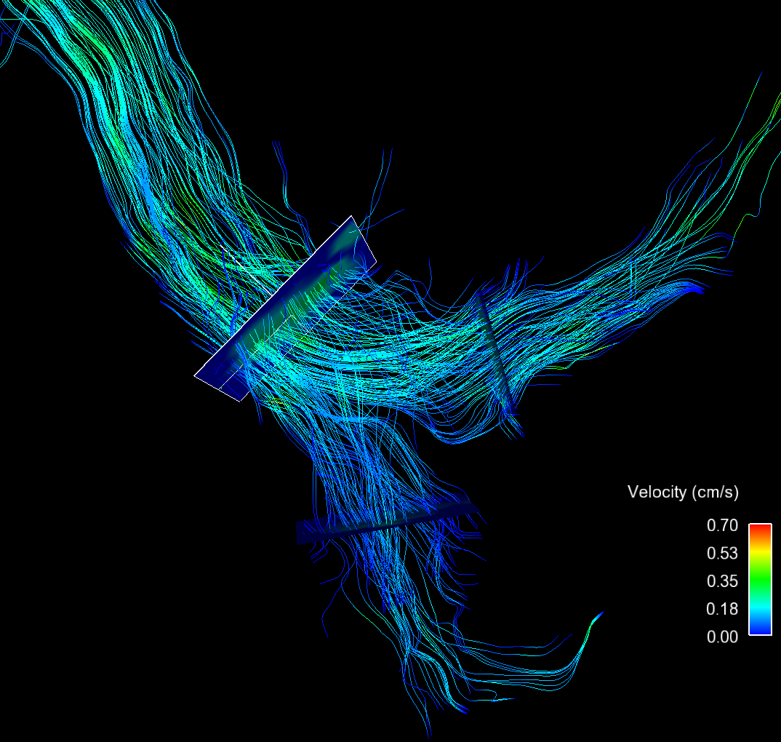

SMV

SV

PV

a

a